Phanteks Eclipse P500 Air Mid Tower Computer Case / Gaming Cabinet - Black | Support ATX, Micro ATX, Mini ITX, E-ATX | Pre-Installed 3 x 140 mm D-RGB Fans in Front - PH-EC500ATG_DBK01

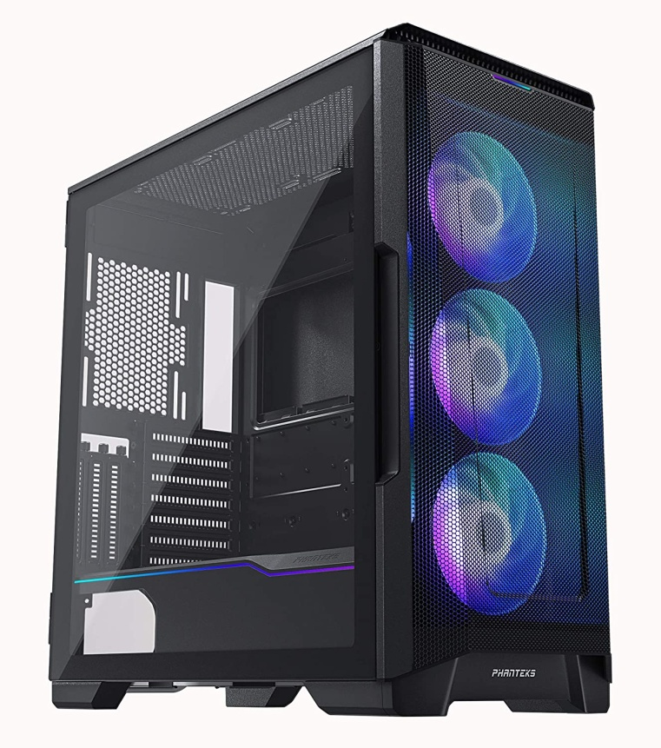

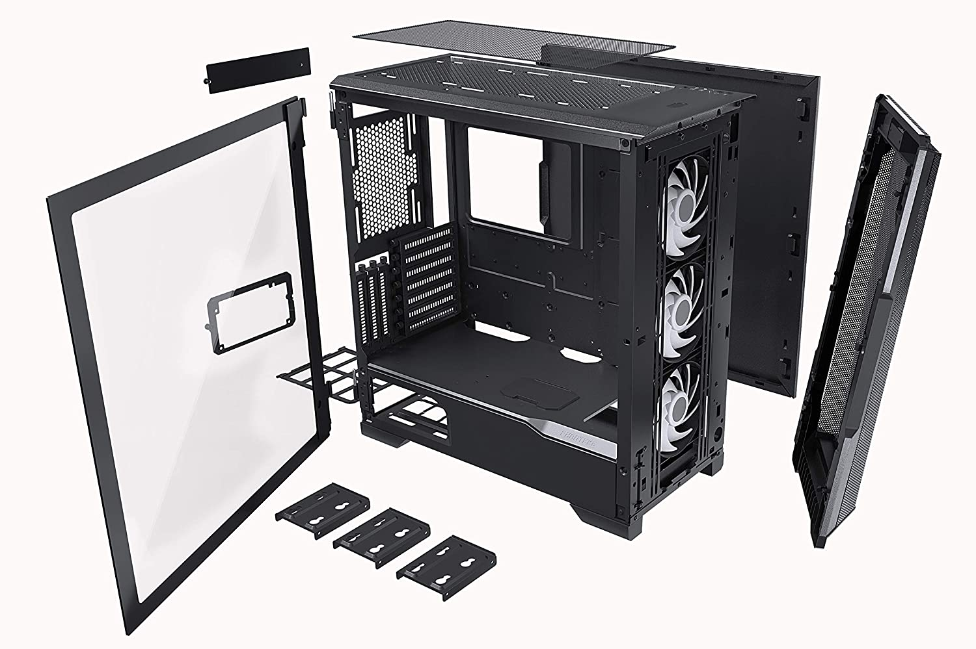

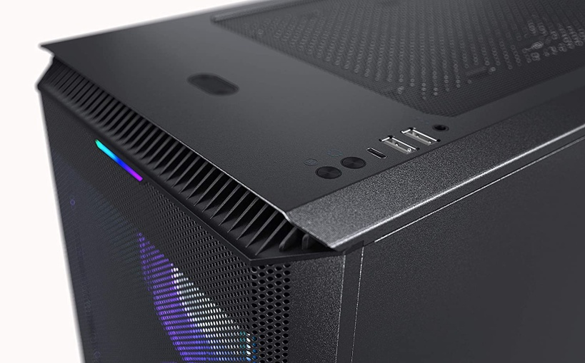

|  |  |
| --- | --- |
| M.R.P.: | ₹17,999 |
| Deal Price: | ₹14,588 |
| You Save: | ₹3,411 (19%) |
|  | Inclusive of all taxes Product details  |  |  | | --- | --- | | Brand | Phanteks | | Colour | Satin Black | | Material | Tempered Glass, Alloy Steel | | Cooling Method | Air | | Fan Size | 140 Millimetres | | Item Weight | 10 Kilograms |  * Black, Midtower, (240 x 510 x 505) mm, Steel Chassis * Storage Capacity : 10 x 3.5" Internal Bay, 3 x 2.5" Internal Bay I PCI slots : 7 + 3 * 2 x USB 3.0, Microphone, Headphone, Power Button, LED Mode Button, LED Color Button * Fan Support : Front - 3 x 120mm, 3 x 140mm I Top - 3 x 120mm, 2 x 140mm I Rear - 1 x 120mm, 1 x 140mm * 5 Years Manufacturer Warranty |